**Articles**

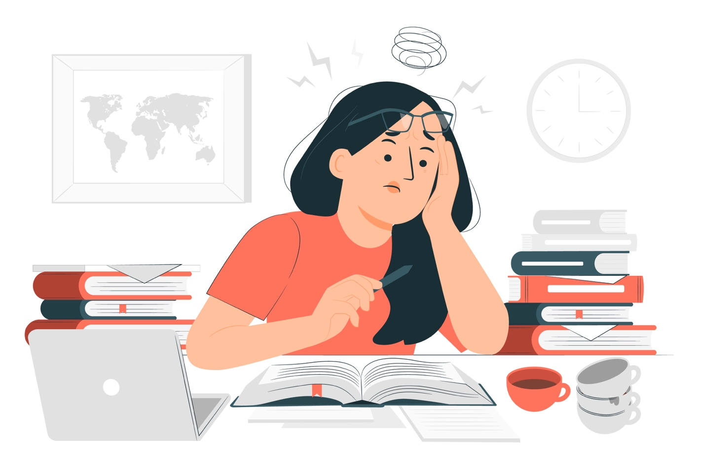

Ways to reduce daily stress

<https://www.health.harvard.edu/staying-healthy/top-ways-to-reduce-daily-stress>

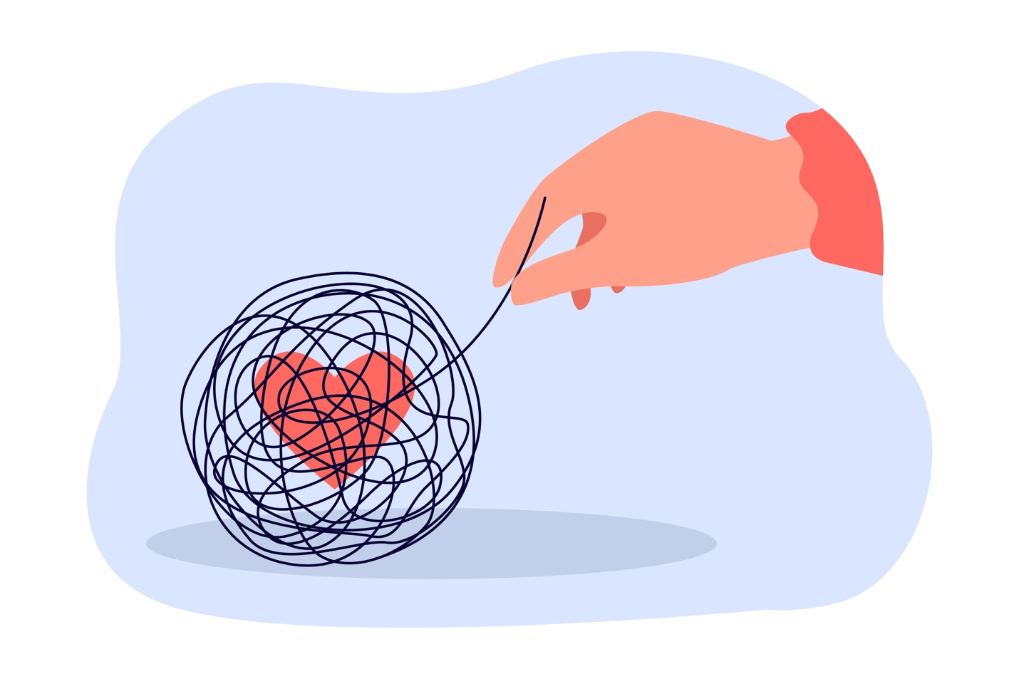

Tips to improve your mental health

<https://www.uab.edu/news/health/item/12852-six-tips-to-improve-your-mental-health>

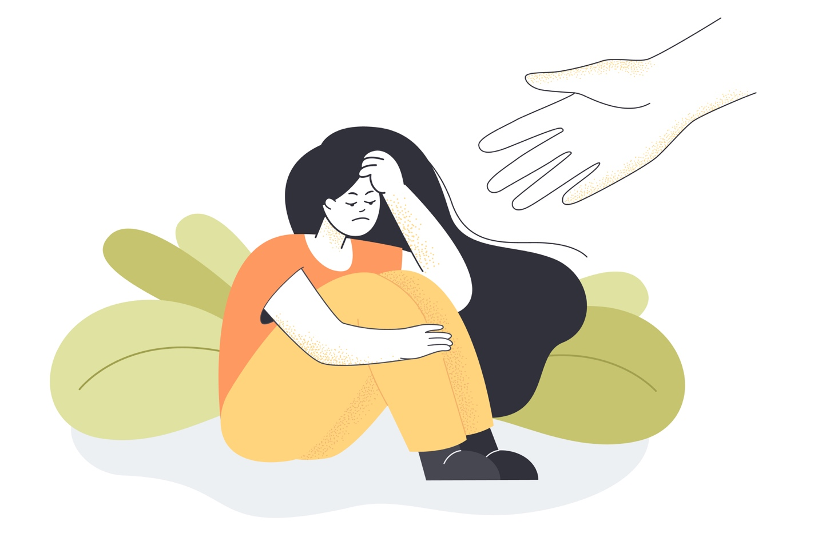

What causes depression?

<https://www.health.harvard.edu/mind-and-mood/what-causes-depression>

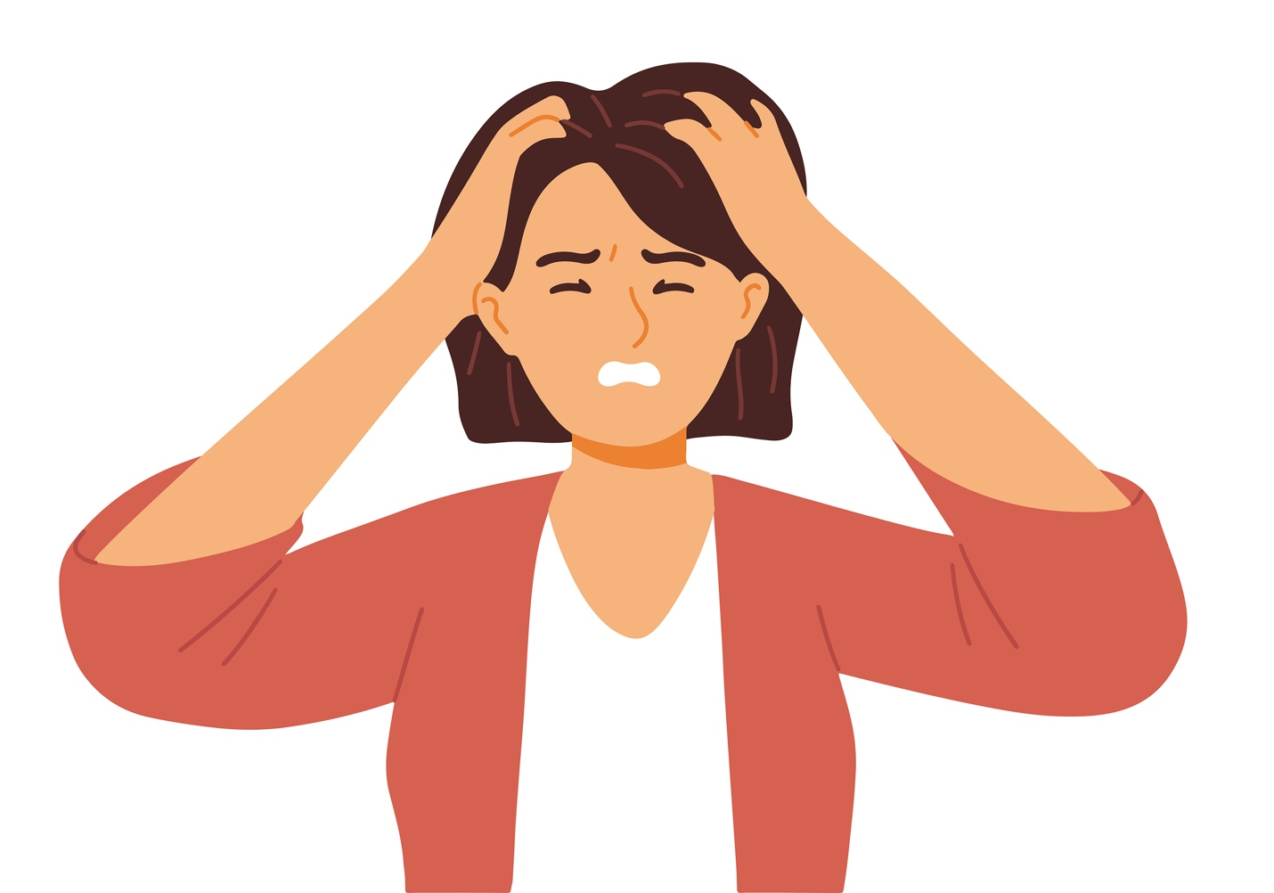

The anatomy of a panic attack

<https://www.nytimes.com/interactive/2022/11/10/well/mind/panic-attack-symptoms-causes.html>

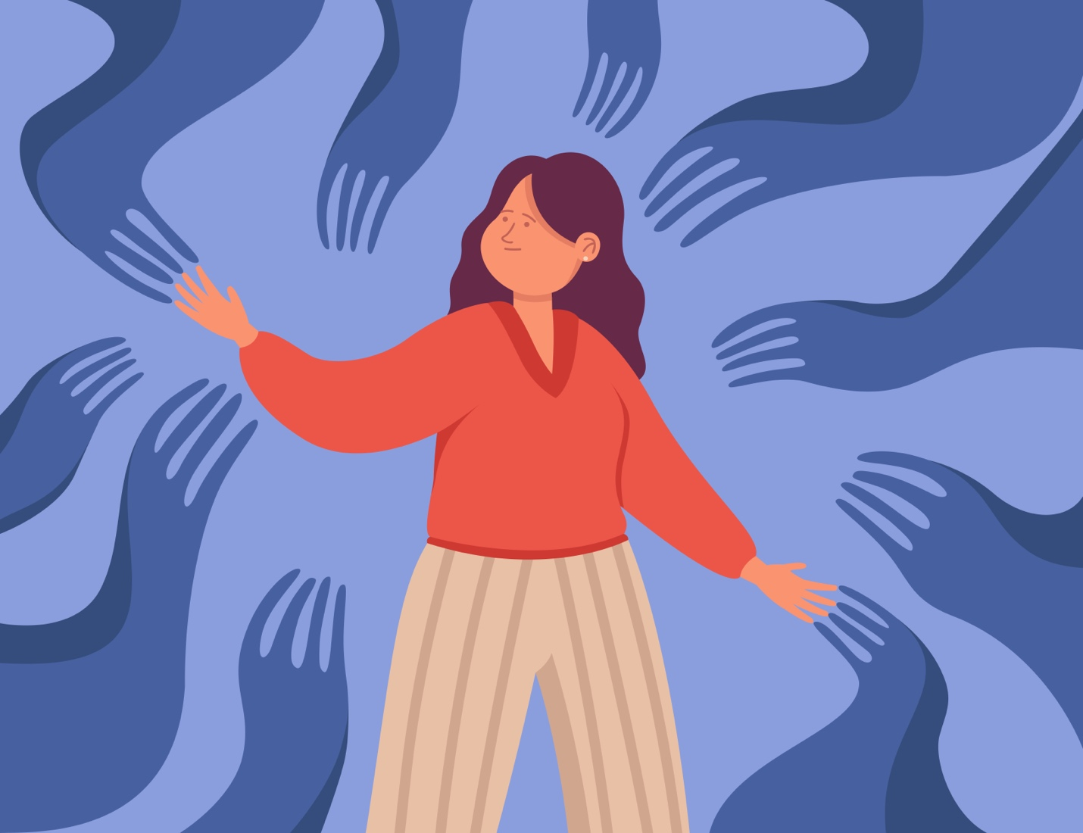

How to cope with panic attacks

<https://www.bcm.edu/news/how-to-cope-with-panic-attacks>

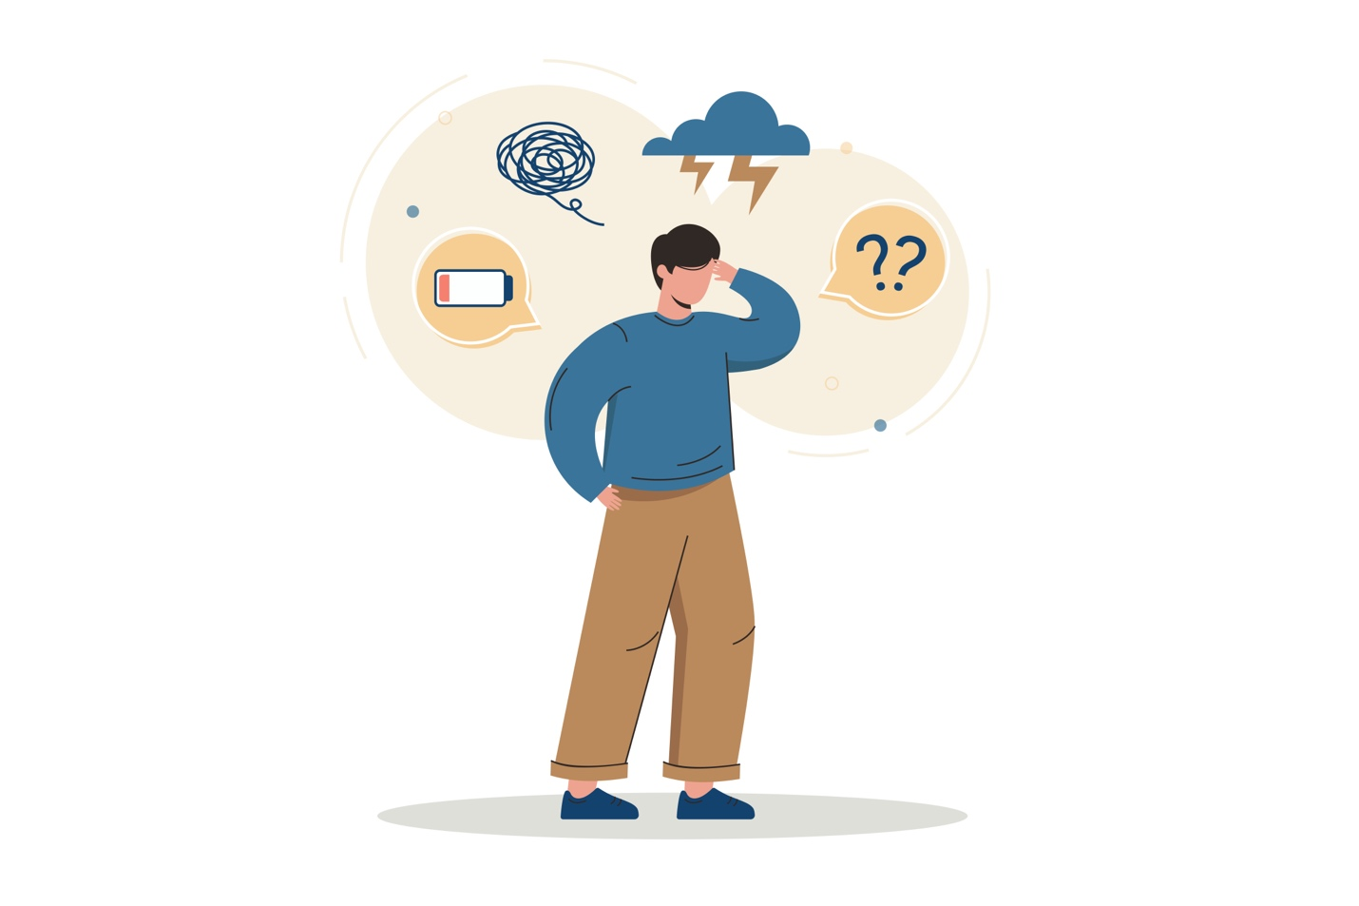

The devastating ways depression and anxiety impact the body

<https://neuroscience.stanford.edu/news/devastating-ways-depression-and-anxiety-impact-body>

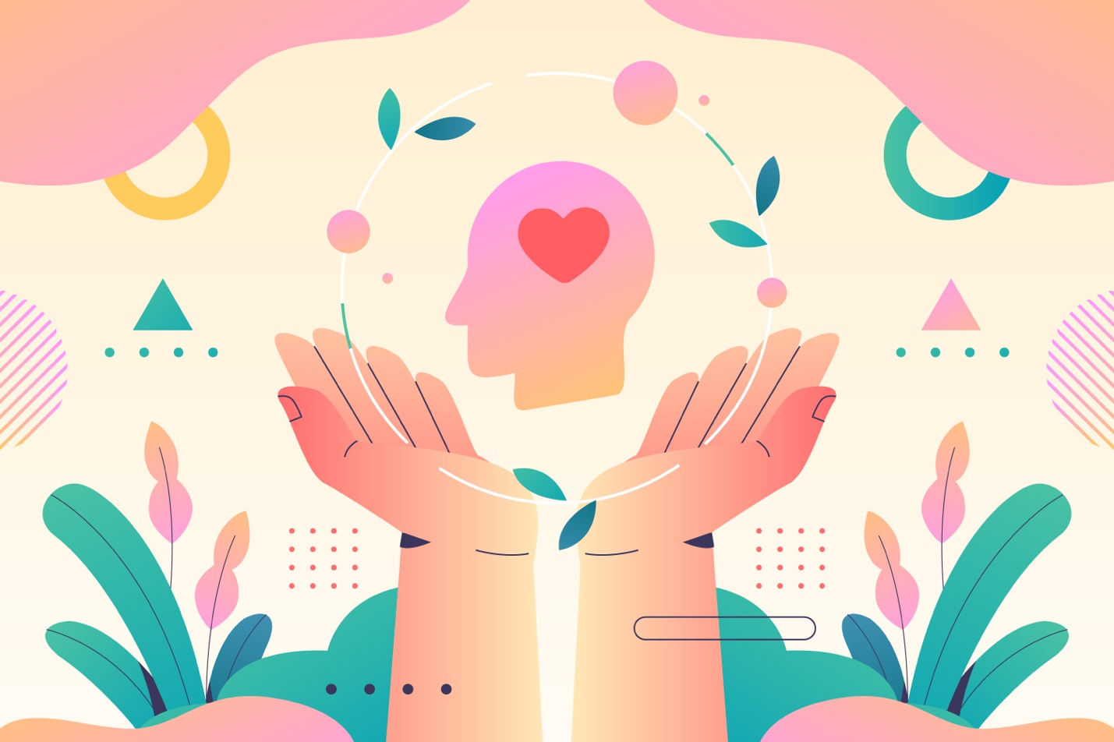

Mental health is just as important as your physical health

<https://healthcare.utah.edu/healthfeed/2022/04/mental-health-just-important-your-physical-health>

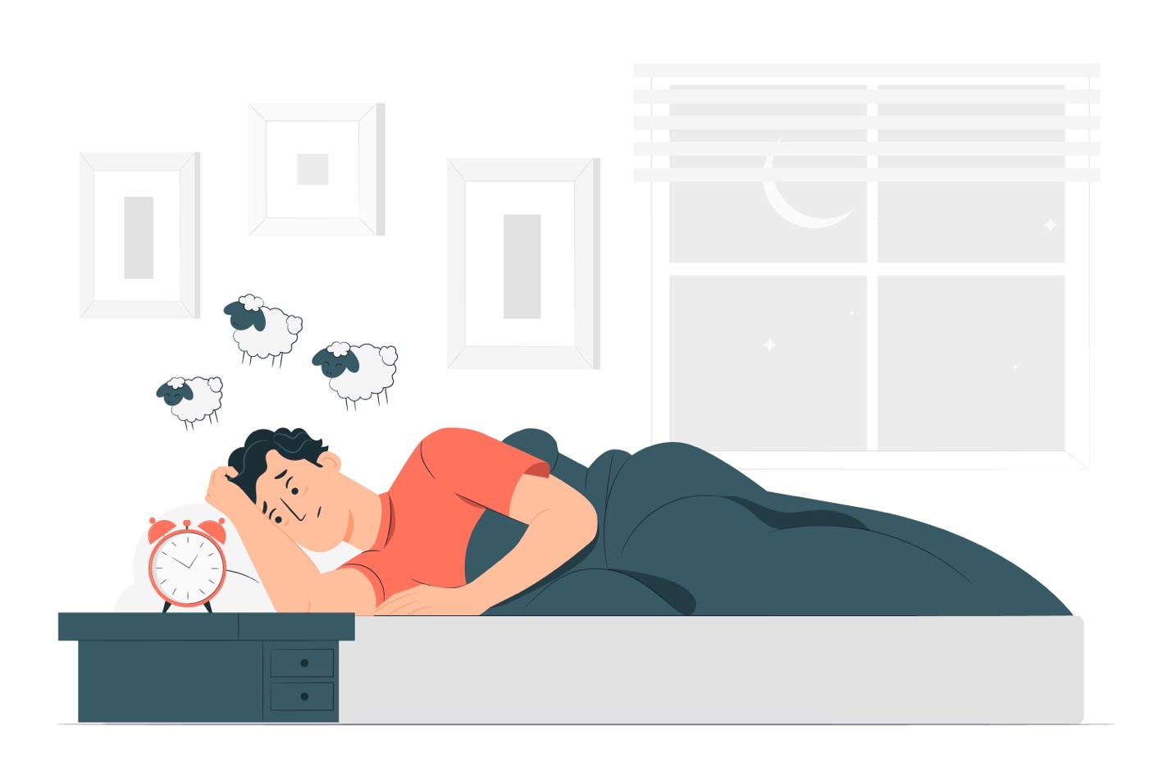

How sleep deprivation impacts mental health

<https://www.columbiapsychiatry.org/news/how-sleep-deprivation-affects-your-mental-health>

**Podcast**

Podcast episode and link:

Introversion vs extroversion

<https://podcasts.apple.com/ae/podcast/introversion-vs-extroversion/id73330911?i=1000628107962>

podcast name: all in the mind

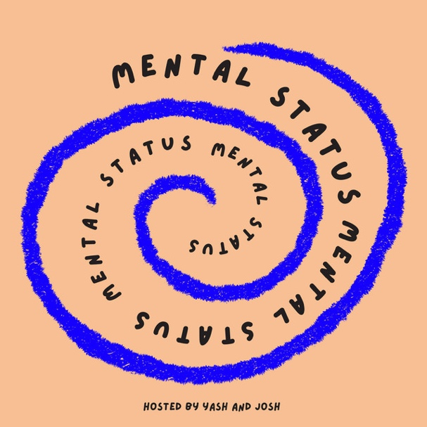

Podcast episode and link:

Deep dive into undergraduate psychology

<https://podcasts.apple.com/ae/podcast/mental-status/id1706572483?i=1000628171468>

Podcast name: Mental status

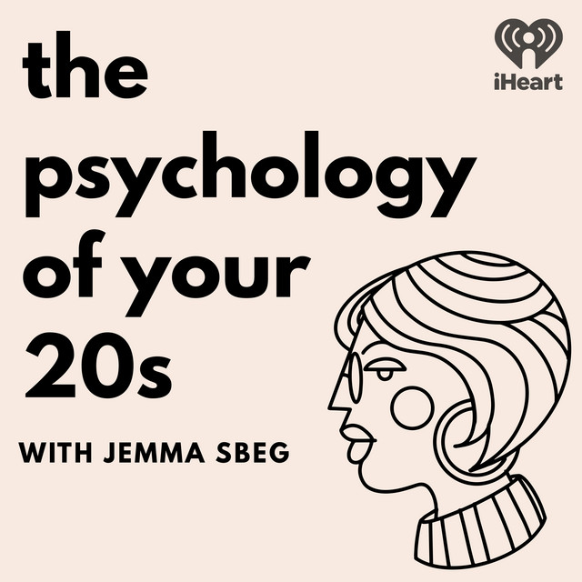

Podcast episode and link :

The psychology of oversharing

<https://podcasts.apple.com/ae/podcast/the-psychology-of-your-20s/id1573710078?i=1000629141184>

podcast name: the psychology of you 20s

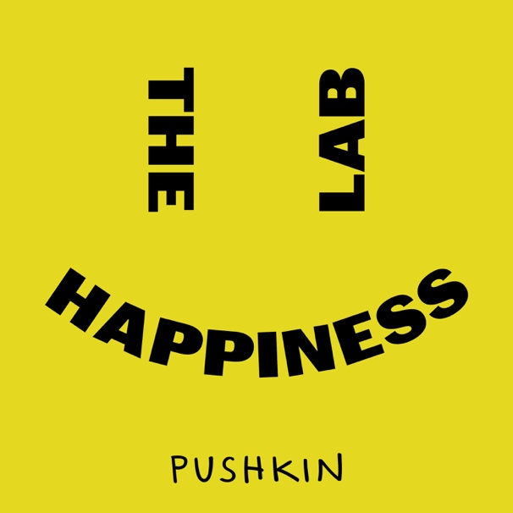

Podcast episode and link:

Big bird has big feelings

<https://podcasts.apple.com/ae/podcast/the-happiness-lab-with-dr-laurie-santos/id1474245040?i=1000627899988>

Podcast name: The Happiness Lab with Dr. Laurie Santos

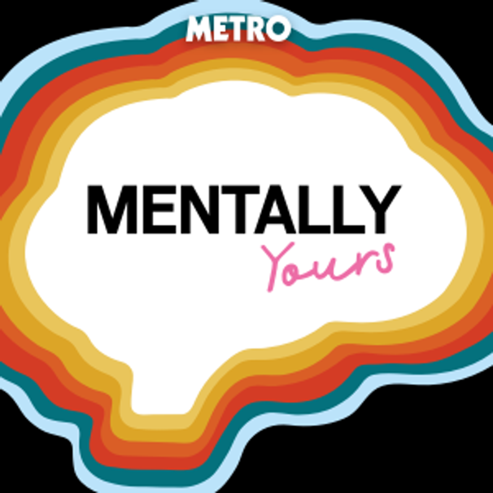

Podcast episode and link:

When Wellness Gets Toxic, With Steph Clarie Smith

<https://podcasts.apple.com/ae/podcast/mentally-yours/id1227701964?i=1000629837526>

Podcast name:

Mentally yours

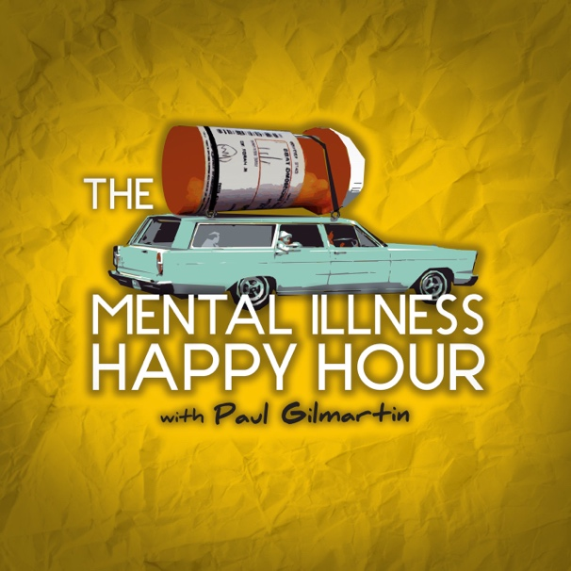

Podcast episode and link:

#658 Childhood Trauma & Self-Perception

<https://podcasts.apple.com/ae/podcast/mental-illness-happy-hour/id427377900?i=1000625640424>

Podcast name:

mental illness happy hour

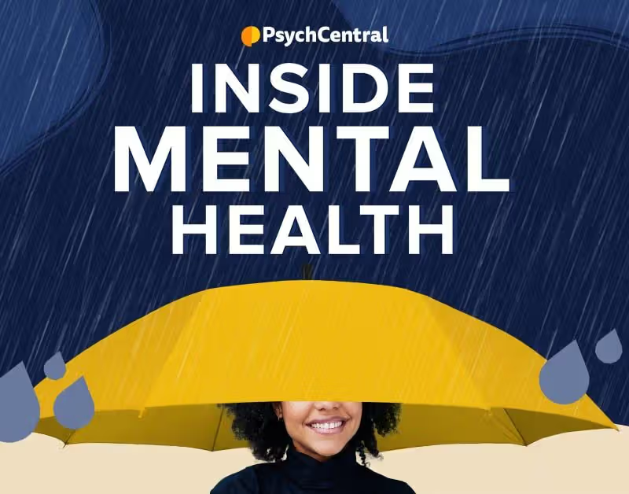

Podcast episode and link:

Discussing suicide with younger kids and preteens

<https://podcasts.apple.com/ae/podcast/inside-mental-health/id1175777581?i=1000627839494>

Podcast name:

Inside Mental Health

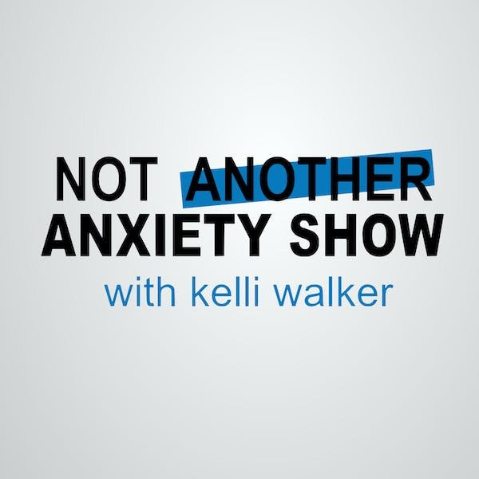

Podcast episode and link:

<https://podcasts.apple.com/ae/podcast/not-another-anxiety-show/id1175495815?i=1000624377432>

Podcast name:

Not Another Anxiety Show

**Videos**

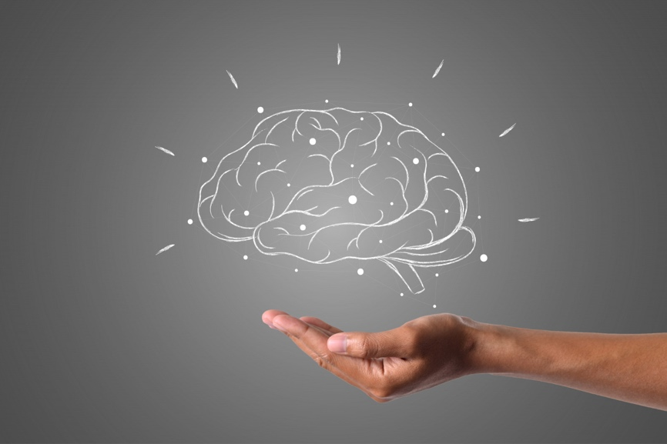

6 Healthy Habits That Make You Mentally Strong

<https://www.youtube.com/watch?v=3hit0p3zZiA&list=WL&index=7>

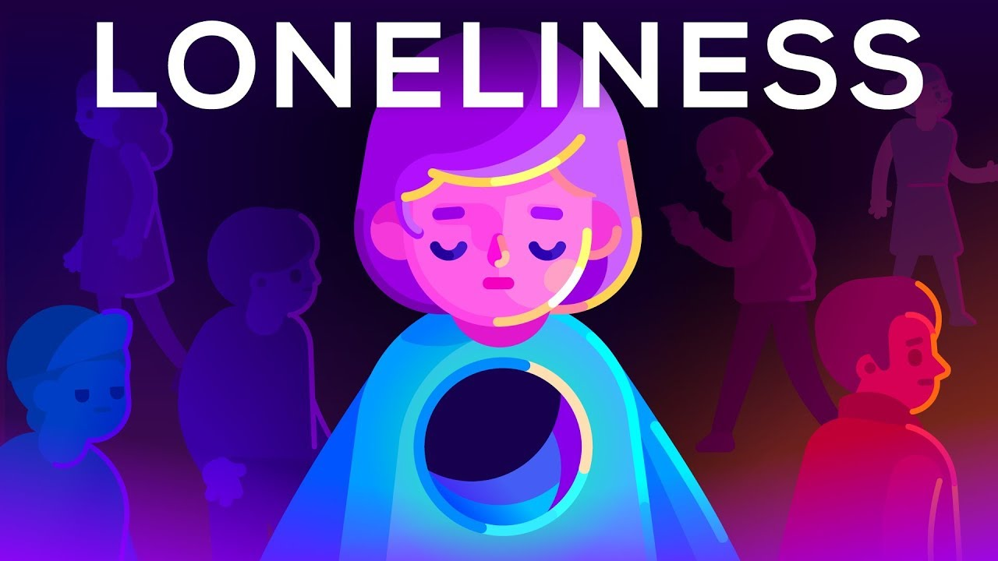

Loneliness

<https://www.youtube.com/watch?v=n3Xv_g3g-mA&list=WL&index=17>

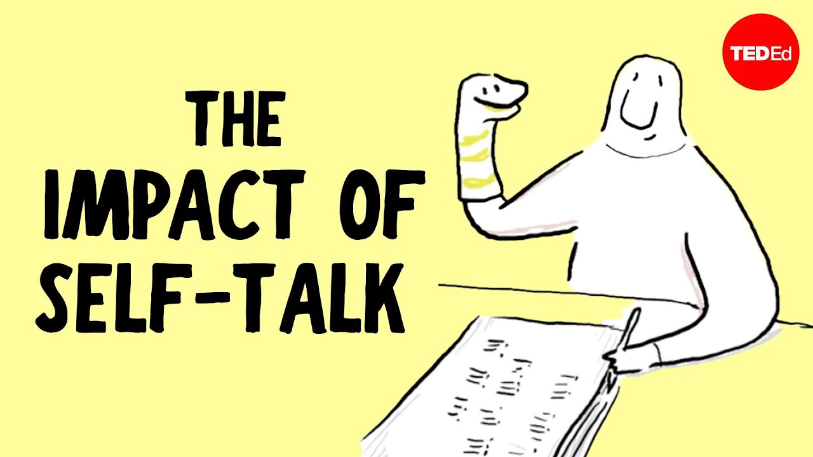

Is it normal to talk to yourself?

<https://www.youtube.com/watch?v=iNyUmbmQQZg>

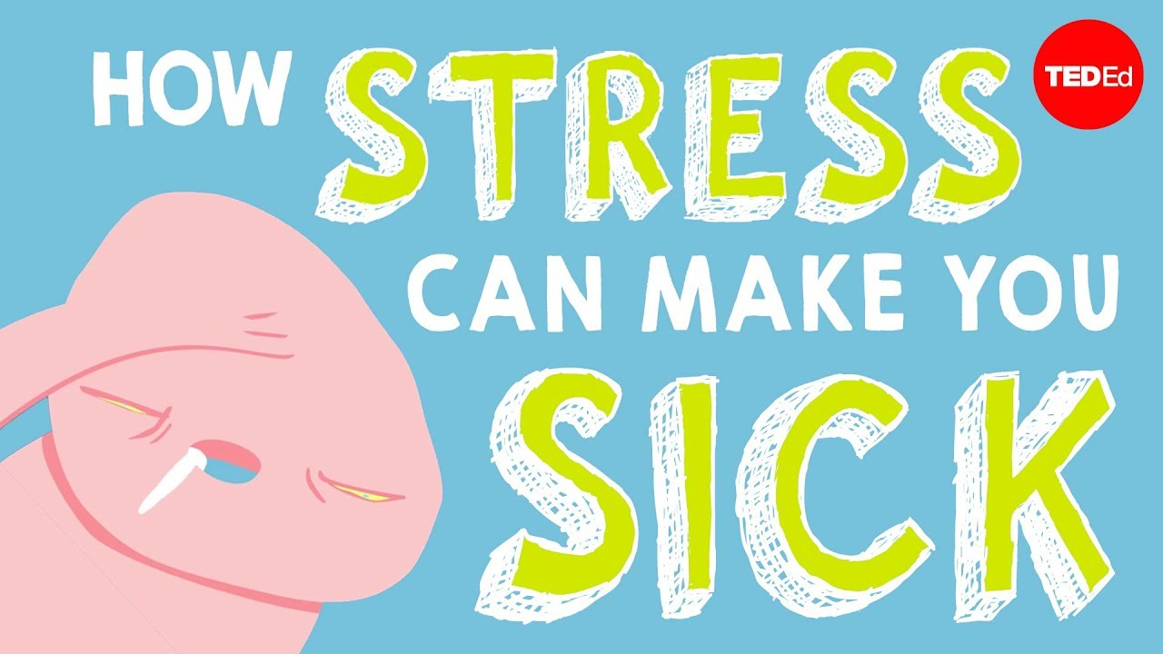

How stress affects your body - Sharon Horesh Bergquist

<https://www.youtube.com/watch?v=v-t1Z5-oPtU>

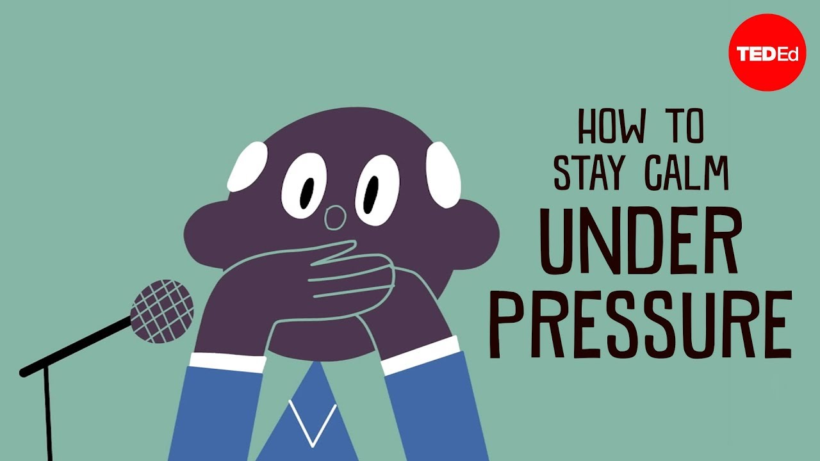

How to stay calm under pressure - Noa Kageyama and Pen-Pen Chen

<https://www.youtube.com/watch?v=CqgmozFr_GM>

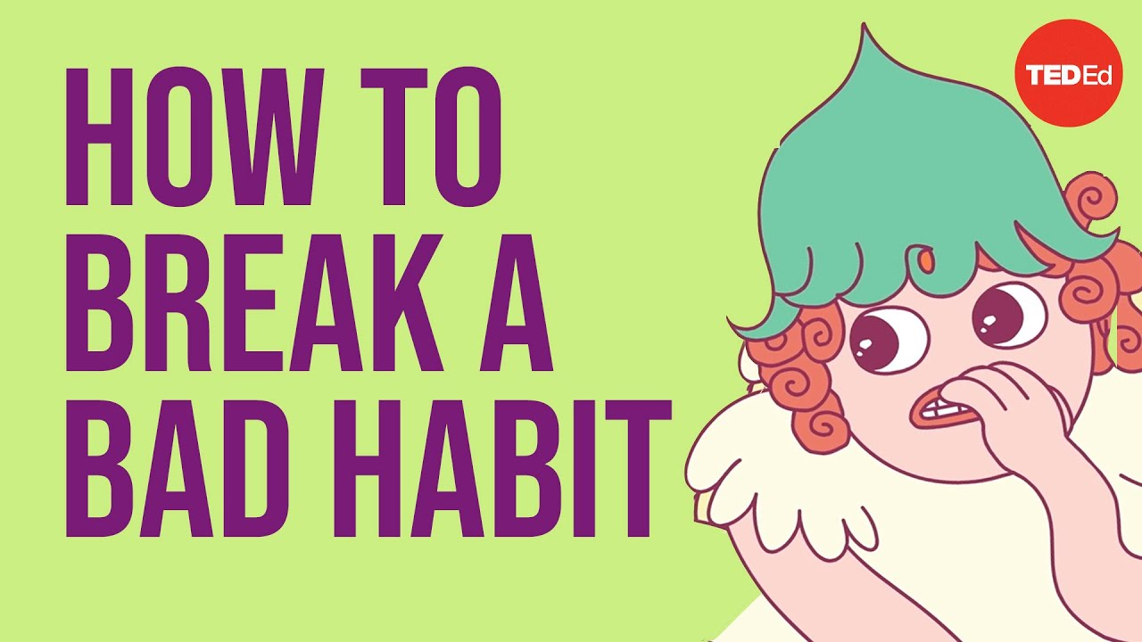

Why is it so hard to break a bad habit?

<https://www.youtube.com/watch?v=wr6fQ4KpbRM>

How sugar affects the brain - Nicole Avena

<https://www.youtube.com/watch?v=lEXBxijQREo>

How stress affects your brain - Madhumita Murgia

<https://www.youtube.com/watch?v=WuyPuH9ojCE>